HTML Comments

**Table of content**

* What is HTML Comment?
* What are the different types of HTML comments?
* What is HTML Comment tag?
* What is valid comment?
* What is invalid comment?

**What is HTML Comment?**

Comment is a part of code which is generally not printed as an output over the browser. Comment is not an important section in your coding if you write a comment into your code it is easy to understand your code to others. When your code is very complex then you can mention the comment to increase the readability of your code. If you want to add comment into your document then you can add comment by using some tags like < ! -- …. --> . whatever you write in between this tag then it will consider as a comment in HTML. Then this comment will ignore by the browser means browser will not print the comment as an output.

**Example-**

<!DOCTYPE html>

<html>

  <head> <!--header starts here-->>

    <title>background color</title>

  </head><!--header ends here-->>

  <body>

    <h1 style="background-color: rgba(94, 243, 243, 0.356)">GEEKY4U.com(learn with passion)</h1>

    <h2 style="background-color: rgb(88, 236, 175)">

      GEEKY4U.com(learn with passion)

    </h2>

    <p style="background-color: rgb(193, 226, 46)">

      GEEKY4U.com(learn with passion)

    </p>

  </body>

</html>

**Output-**

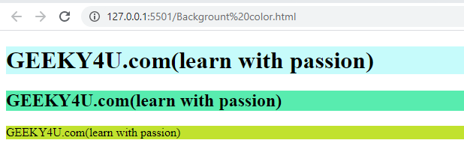

In the above example of background color, Content which is written in the comment section has ignored by browser.

**What are the different types of HTML comments?**

HTML will allow different types of comments to make your code simple. HTML supports single line as well as multiline comment.

**Multiline comment-**

HTML consists of single line as well as multiline comments. HTML supports both single line and multiline comments. Multiline comment means you can add multiple line in the comment. Multiple comment written in between < ! -- …. -- > tag.

**Example-**

<!DOCTYPE html>

<html>

  <head>

    <meta charset="UTF-8" />

    <title>multiline comment </title>

  </head>

  <body>

      <!--

    This is an example of multiline comment--

    You can mention here more than 2 line of comment--

    Which is considered as multiline comment.

      -->

    <h1>This is a main content------ </h1>

  </body>

</html>

**Output-**

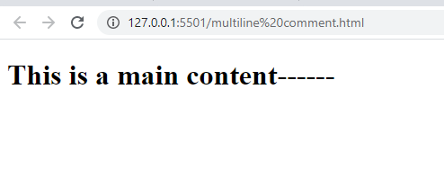

**Conditional comment-**

Conditional comment is also supported by HTML but not supported by all the browser. Only internet explorer will support the concept of conditional comment. Conditional comments consist of some conditions in the form of instructions.

**Example-**

<!DOCTYPE html>

<html>

  <head>

    <meta charset="UTF-8" />

    <title>conditional comment </title>

  </head>

  <body>

      <!--if[IE]>

        main instruction for IE

      <![end if]-->

    <h1>This is a main content------ </h1>

  </body>

</html>

**Output-**

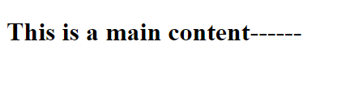

**What is HTML Comment tag?**

For writing comment in the code comment tag is important. You can add important instructions or notification in the comment section so that your code will look simpler and easy to understand.

**Syntax-** <!-- ….comment here… -->

**Example-**

<!DOCTYPE html>

<html>

  <head>

    <meta charset="UTF-8" />

    <title>comment tag </title>

  </head>

  <body>

    <!--you can add comment here-->

    <h1>My main content here----- </h1>

  </body>

</html>

**Output-**

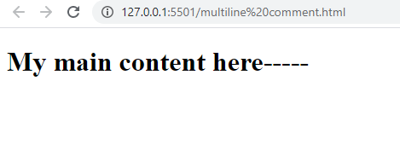

**What is valid comment?**

The comment is considered as valid comment When there is no space between <!—do not givw any space after ! mark -->

**Example-**

<!DOCTYPE html>

<html>

  <head>

    <meta charset="UTF-8" />

    <title>valid tag </title>

  </head>

  <body>

    <!--you can add comment here-->

    <h1>My main content here----- </h1>

  </body>

</html>

**Output-**



**What is invalid comment?**

The comment is considered as invalid comment When there is space after ( ! ) exclamatory mark. There is no single space required after (<) open angle bracket and (!) exclamatory mark otherwise comment will considered as invalid comment and comment will also show in output.

**Example-**

<!DOCTYPE html>

<html>

  <head>

    <meta charset="UTF-8" />

    <title>invalid tag </title>

  </head>

  <body>

    < !--you can add comment here-- >

    <h1>My main content here----- </h1>

  </body>

</html>

**Output-**

